**DBS MOT Interview Questions**

**Overview:**

There will be two rounds of interview, each round starts with programming questions where we need to share the screen and write the code and there will be a discussion on the code written on how to improve the algorithm and efficiency if the code is correct. After that theoretical questions on core java, design patterns, collections, spring, spring boot.

**Round 1:** 1 hr 10 mins

Q1: given input stream of data as input write a program to write the data to a file?

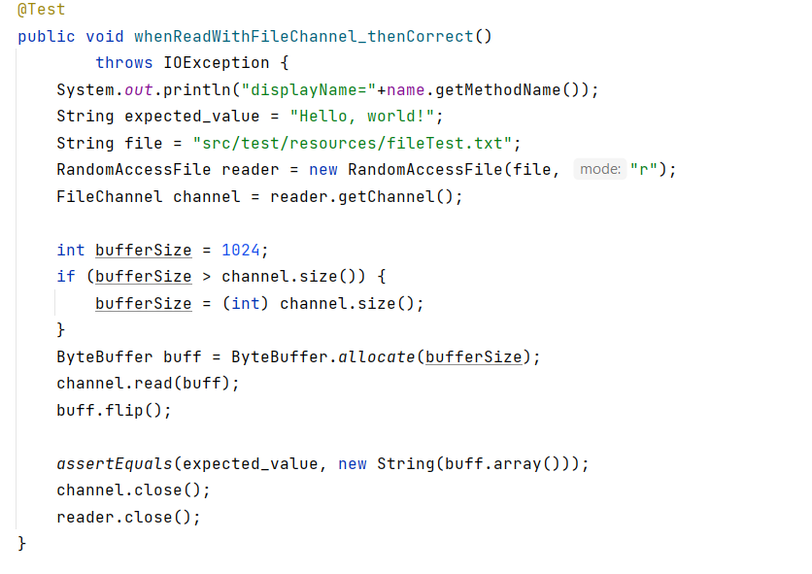

Q2: write a program which takes the string input “manual/abc.txt” and returns the output string in the format “manual/todays_date/abc.txt”

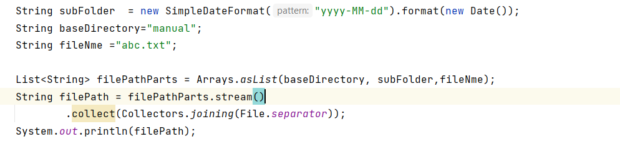

Q3: given the list of string as input as below

[“a:1”, ”b:2”, ”c:3”]

write a program to return a map as follows

[Key: a, value: 1; Key: b, value: 2; Key: c, value: 3]

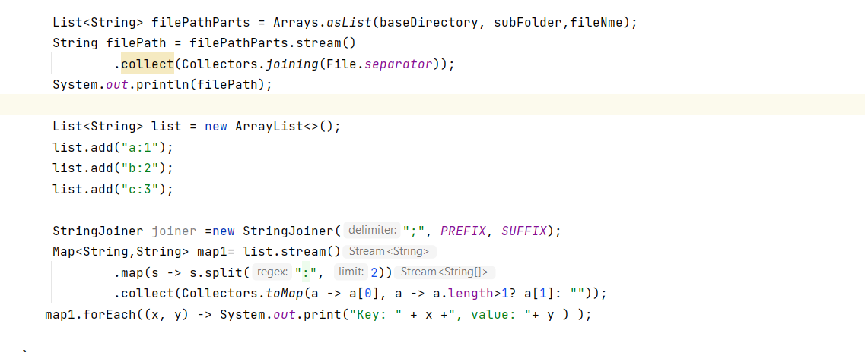

Q4: explain how spring ioc container works?

Q5: how to control the instantiation of beans in spring ioc from specific packages?

Q6: I am adding an element into an array list while iterating, what is the output?

* Runs into infinite loop

Q7: how to instantiate a class from a third-party library as a spring bean?

*package com.tarkshala;*

*import org.springframework.context.annotation.Bean;*

*import org.springframework.context.annotation.Configuration;*

*@Configuration*

*public class ConfigurationAnnotationExample {*

*@Bean*

*public AmazonDynamoDBClientBuilder getAmazonDynamoDBClientBuilder() {*

*return AmazonDynamoDBClientBuilder.standard().withRegion(Regions.AP_SOUTH_1);*

*}*

*@Bean*

*public DynamoDBMapper getDynamoDBMapper(final AmazonDynamoDBClientBuilder builder) {*

*return new DynamoDBMapper(builder.build());*

*}*

*}*

*package com.tarkshala;*

*import org.springframework.beans.factory.annotation.Autowired;*

*import org.springframework.stereotype.Component;*

*@Component*

*public class BillDAO {*

*private DynamoDBMapper dynamoDBMapper;*

*@Autowired*

*public BillDAO(final DynamoDBMapper dynamoDBMapper) {*

*this.dynamoDBMapper = dynamoDBMapper;*

*}*

*public void create(BillDO billDO) {*

*dynamoDBMapper.save(billDO);*

*}*

*}*

Q8: I have a map and I did the following operations

Map.put(“head”, 10);

Map.put(“head”, 12);

What is the output of map.get(“head”)?

Q9: Question on factory design pattern, interviewer explained use case of factory design pattern and then asked which design pattern will you use?

**Round 2:** 45 mins

Q1: write a program to reverse a string using recursion?

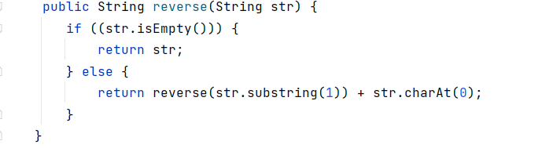

Q2: given a paragraph of text and a word to search as inputs, write a program to find the line numbers where the search word is present in the input text?

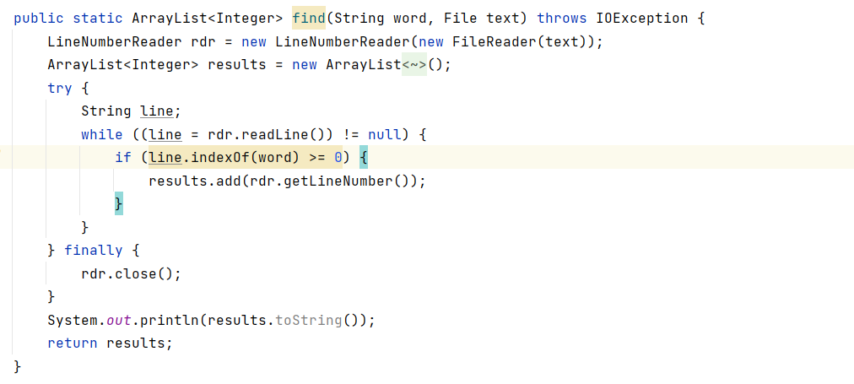

Q3: given a paragraph of text, write a program to find unique words with their count in the given paragraph?

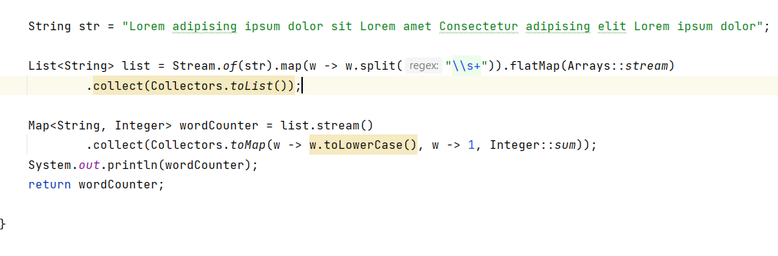

Q4: you wrote a web service and exposed it, there are 10 clients who are calling this service, how do you know which client is calling and how many times they are hitting your service?

Q5: follow up question to previous question (Q4). There are 20 services exposed by you, how do you implement the logic to log requests, responses, errors/exceptions?

Note: expecting spring AOP as the answer.

Q5: how do you secure your service?

<https://www.youtube.com/watch?v=RVvKPP5HyaA> - spring AOP

<https://www.youtube.com/watch?v=EifpajKQOOQ> – Spring security

Prepared by Anvesh Valeti.